

Sustainability Assessment Module
  - SPECIFICATION

 | Name | Role | Digitally signed
Author | Csenge Varjas | Junior Product Owner | Mar 20, 2025 10:18:04 (UTC)
Reviewer | Mark Bijl | CTO | Mar 20, 2025 10:18:43 (UTC)
Approver | Eelco de Jong | Managing Director | Mar 20, 2025 12:44:42 (UTC)
QA | Nicola Caristo | Quality Manager (Interim) | Mar 27, 2025 18:07:57 (UTC)

Table of Contents
1. Introduction 2
2. Glossary 2
3. Overview of CO₂ and waste calculations 2
4. Sustainability data input 3
4.1. Reusability 3
4.2. Materials 4
4.3. Reverse logistics 5
4.4. Lane set-up 6
5. Calculation method 6
5.1. Transport 7
5.1.1. Distance Calculation methods 7
5.1.2. Emission calculations 8
6. Verification 11
7. Results 11
8. Sources and references 11
8.1. Emission factor production and end-of-life 11
8.2. Reverse logistics mode factor 15
8.3. NTM references 16
9. Change History 17

Introduction
Validaide’s Sustainability Assessment Module is a module within Validaide that allows users to calculate, monitor, and report greenhouse gas emissions and waste from pharmaceutical transport.
The key strength of this application is the transparent emission calculation of a door-to-door transport lane, including the emissions from the used tertiary packaging and the reverse logistics of empty packaging. We designed the methodology to achieve the highest accuracy in air freight emissions, where the vast majority of emissions originate.
The methodology of the Sustainability Assessment Module is based on the study “Operational and tactical levers to reduce carbon emissions in temperature-sensitive freight transportation for pharmaceuticals” by MIT University's Center for Transportation and Logistics: Lehmann, Winkenbach, Janjevic (2023). Transport data is powered by the Network for Transport Measures (NTM).
This documentation describes the method used to calculate greenhouse gas emissions and waste for the Sustainability Assessment Module. It is structured in a way that first shows how users need to add data. Then, we describe how the provided data is used to calculate CO₂ emissions and waste.

Glossary
Well-to-Wheel: Well-to-wheel emissions account for all the greenhouse gases created from getting the fuel out of the ground to moving the vehicle.
Product Cabon Footprint (PCF): It refers to the total amount of greenhouse gases (GHGs) emitted during the lifecycle of a product. This includes all stages from raw material extraction, manufacturing, transportation, use, and disposal.
Radiative Forcing Index: the RFI helps us understand how different substances and activities, like cloud formation from airplanes, influence global warming compared to carbon dioxide alone. An RFI greater than 1 means the factor has a greater warming effect than CO₂ alone, while an RFI less than 1 means it has a lesser effect.
CO2e: A standard unit used to measure and compare the impact of different greenhouse gases on global warming. Each type of greenhouse gas has a different potential to trap heat in the atmosphere. CO2e allows us to express the impact of these gases in terms of the amount of CO₂ that would have the same global warming effect.
Volumetric weight: Volumetric weight, also known as dimensional weight, is a calculation used in the shipping and logistics industry to determine the cost and CO₂ emissions of transporting a package based on its dimensions rather than its actual weight. This method is used because the space a package occupies on a vehicle can be more valuable than its weight, especially for lightweight, bulky items. The volumetric weight is calculated using the dimensions of the package and a specific conversion factor. The dimensional factor varies depending on the carrier and mode of transportation but is commonly set at 166 kilogram per cubic meter for air freight. To calculate CO₂ emission, the volumetric weight is compared to the actual weight. The greater of these two factors is then used to calculate CO₂ emissions.

Overview of CO₂ and waste calculations
In Validaide’s Sustainability Assessment Module, users can calculate the emissions of pharma transport lanes. To do that, users will need to set up a lane or use an existing one in Validaide. For these lanes, users will need to define each transport leg and select the corresponding packaging type used in this lane. The packaging type has associated characteristics, which will be used to calculate the emission of a lane. This approach allows users to model an entire lane from door-to -door with minimal additional efforts compared to the existing lane-risk assessment tools available on Validaide. The results of the analysis are the CO₂ emissions and waste per m³ of transported pharmaceutical products, as well as for a single transport. However, for comparability reasons amongst different packaging sizes, we recommend always to use the values normalized per m³.

Sustainability data input
In order to calculate the CO₂ and waste, Validaide has introduced three sustainability input fields, called “Modify Sustainability,” which need to be filled in by the packaging provider. These fields must be filled in for each packaging separately.

Reusability
Indicating reusability is crucial for calculating CO₂ emissions from production and end of life, and for determining if reverse logistics emissions apply.
Therefore, in this section, packaging providers need to specify if their product is single-use or multi-use. In case it is multi-use, packaging providers can specify their JYP number range for automated verification (see more info on chapter Verification). If JYP numbers are not available, packaging providers need to submit another kind of evidence regarding reusability through the upload function.
The default value for reusability is single-use.
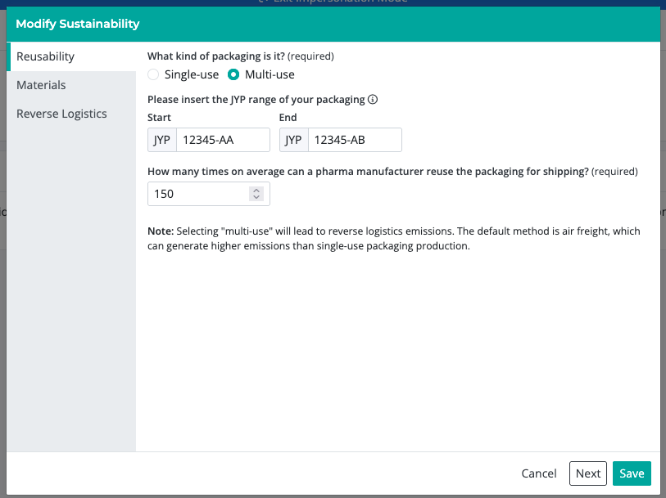
Figure 1 - Reusability input field in Validaide

Materials
The materials that a packaging type consists of are crucial for calculating the CO₂ emissions from production and end of life of the packaging type.
Therefore, in this section, packaging providers need to specify the material compounds of their packaging. Unaccounted weight will be allocated to “other materials”, which has the same emission factor as the highest intensity material. If the precise material is not available, packaging providers should choose the most similar material available on the list. The information in this section is private to packaging providers.
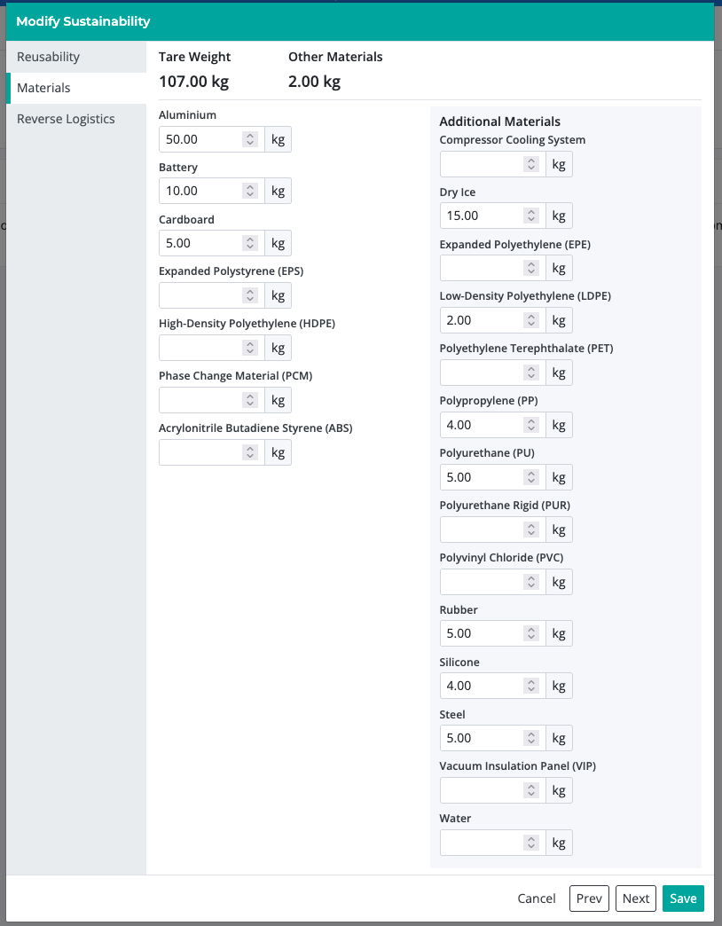
Figure 2 – Materials input field in Validaide

Reverse logistics
Reverse logistics are crucial for calculating CO₂ emissions of reusable packaging types.
Therefore, in this section, packaging providers need to provide the share of this packaging, which gets reversed to the origin region without containing pharma products. Furthermore, packaging providers will need to specify the share of the transport mode that they use to reverse this packaging type. To ensure a level playing field, packaging providers need to upload proof regarding the share and transport mode of their reverse logistics.
All of the data in these fields need to correspond to a specific year, which needs to be indicated.
The default values are 100% reverse, and 100% air freight. This section is only available for multi-use packaging types.
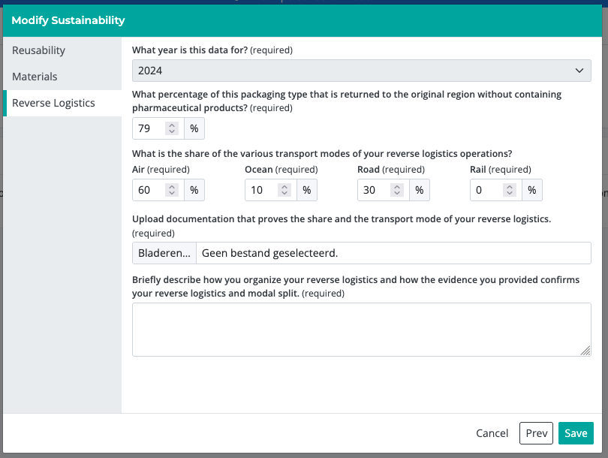
Figure 3 - Reverse logistics input field in Validaide

Lane set-up
The setup of lanes has not been impacted by the Sustainability Assessment Module. CO₂ emissions will be automatically added to lanes, when packaging providers submit their data. However, freight forwarders will need to link the specific packaging to the lane. In the past, freight forwarders could link the general type of pharma packaging (e.g., advanced passive) to a lane. To calculate CO₂ emissions and waste, the precise packaging needs to be linked. This will require some additional effort by the freight forwarders in case this data has been missing.

Calculation method
Validaide calculates the CO₂ emissions and waste for the transport of one packaging type, including pharma product, on a lane. To ensure comparability between small and large packaging types, Validaide also calculates the emissions and waste per cubic meter of pharma product. To accurately do that, Validaide calculates the emissions of the following sub-steps:
- Transport, including all specified legs.
- Production and end of life of packaging types
- Reverse logistics for multi-use packaging
- Waste
Pre-conditioning, which is the step of preparing a temperature-controlled packaging, is excluded, as this usually accounts for less than 1% of overall emissions (see MIT study). All emissions are well-to-wheel emissions, including all relevant greenhouse gas emissions. The results are displayed in CO₂e. For aviation emissions, we also consider an RFI of 2 as recommended by the described MIT study.
In the following chapter, we describe the methodology used to calculate these steps.

Transport
Validaide can calculate the emissions of four different transport modes, which are;
- Airplane
- Truck
- Container ship
- Cargo train
The following section describes first how Validaide calculates the distance of each transport mode, followed by their calculation method. To calculate emissions, Validaide uses an API to the Network for Transport Measures (NTM).

Distance Calculation methods
The following approaches are used to calculate the distances of each transport mode:

Airplane and train
The module calculates distances using the Haversine Formula to calculate the Great Circle Distance (GCD). Furthermore, it uses the Distance Adjustment Factor (DAF) to calculate the estimated distance, by using the following formula:
$$DAF=\frac{GCD+95km}{GCD}$$
$$Distance=GCD*DAF$$
Whereas:
- DAF = Distance Adjustment Factor
- GCD = Great Circle Distance = Shortest distance between two points on a sphere
This approach is adopted from ISO14083 and is fairly accurate for air freight. However, it will underestimate the distance of freight trains. Validaide’s Sustainability Assessment Module is designed in particular for high-value pharma transports, where freight trains are less frequently used. Therefore, the overall resulting difference will not significantly impact the majority of use cases.

Road
To calculate road distances, a Google Maps API is used.

Sea
For ocean freight, SeaRoute from Eurostat is used.

Emission calculations
Validaide calculates the CO₂ emissions of a lane, which can consist of one or multiple legs:
  - Pre-Carriage = Transport of packaging from loading point to origin airport/port/station
  - Transport = Main transport
  - On-carriage = Transport from destination airport/port/station to the consignee
In addition, it can calculate the emission for four different transport modes:
  - Road
  - Air
  - Sea
  - Train
Validaide uses an API to get information regarding the plane type on a lane. However, CO₂ calculations are currently limited to a few airplane types. If the actual airplane type is not available, Validaide will choose the B777-200 as the default plane.

Transport mode air
The following parameters are sent to NTM via an API:
- Volumetric Weight: We select the volumetric weight method to allocate emissions.
- Shipment Weight: The weight of a single Packaging Type plus the weight of the product inside a single Packaging Type. As the product weight is not specified in Validaide, we assume a density of 100kg/m³ of pharma product. The payload of the Packaging Type gets multiplied with this density and added to the tare weight of the Packaging Type as defined in Validaide.
- Shipment Volume: The outer volume of the selected Packaging Type is used.
- Plane Type from the Leg
- Distance as described in the section Distance Calculation Method (5.1.1).
NTM allows for additional parameters as inputs, such as load factors. However, to increase the ease of use, all other parameters are the default parameters as defined by NTM.
As a result of this request, the response from NTM is the emissions of the transport of a single Packaging Type. Validaide then multiplies the response by a Radiative Forcing Index (RFI) of 2, which follows the recommendation of the MIT study described above. More information regarding the calculations can be found on the NTM website (see links at the end of the document).

Transport mode road
The following parameters are sent to NTM for calculation:
- Weight-based: We select the weight-based method to allocate emissions.
- Shipment Weight: The weight of a single Packaging Type plus the weight of the product inside a single Packaging Type. As the product weight is not specified in Validaide, we assume a density of 100kg/m³ of pharma product. The full payload of the Packaging Type, as indicated by the packaging provider, gets multiplied with this density and added to the tare weight of the Packaging Type as defined in Validaide.
- The selected Truck Type is a Rigid Truck 14 – 20t
- Distance as described in the chapter Distance Calculation Method (5.1.1).

NTM allows for additional parameters as inputs, such as load factors. However, to increase the ease of use, all other parameters are the default parameters as defined by NTM.
As a result of this request, the response from NTM is the emissions of the transport of a single Packaging Type. More information regarding the calculations can be found on the NTM website.

Transport mode train
The following parameters are sent to NTM for calculations:
- Weight-based: We select the weight-based method to allocate emissions.
- Shipment Weight: The weight of a single Packaging Type plus the weight of the product inside a single Packaging Type. As the product weight is not specified in Validaide, we assume a density of 100kg/m³ of pharma product. The full payload of the Packaging Type, as indicated by the packaging provider, gets multiplied with this density and added to the tare weight of the Packaging Type as defined in Validaide.
- The selected Train Type is an electric cargo train.
- Distance as described in the section Distance Calculation Method (5.1.1).
NTM allows for additional parameters as inputs, such as load factors. However, to increase the ease of use, all other parameters are the default parameters as defined by NTM.
As a result of this request, the response from NTM is the emissions of the transport of a single Packaging Type. More information regarding the calculations can be found on the NTM website.

Transport mode sea
The following parameters are sent to NTM for calculation:
- Weight-based: We select the weight-based method to allocate emissions.
- Shipment Weight: The weight of a single Packaging Type plus the weight of the product inside a single Packaging Type. As the product weight is not specified in Validaide, we assume a density of 100kg/m3 of pharma product. The full payload of the Packaging Type, as indicated by the packaging provider, gets multiplied with this density and added to the tare weight of the Packaging Type as defined in Validaide. The selected ship type is a container ship
- The selected water body type is oceans.
- Distance as described in the section Distance Calculation Method (5.1.1).
NTM allows for additional parameters as inputs, such as load factors. However, to increase the ease of use, all other parameters are the default parameters as defined by NTM.
As a result of this request, the response from NTM is the emissions of the transport of a single Packaging Type. More information regarding the calculations can be found on the NTM website.

Production and end-of-life
Validaide calculates the emissions of the production and end of life of the Packaging Type using the formula described below.
$$packagingEmissions=\frac{Sum\left(weightPerMaterial*materialEmissionFactor\right)}{reusability}$$
Whereas:
- packagingEmissions = Total CO2e of the production and end of life process in metric tons.
- materialEmissionFactor = Emission factor of the production and end of life of the selected packaging material. These factors are mostly from Ecoinvent (see sources at the end of the document).
- reusability = Indicated number of reuses of selected packaging type

Reverse logistics
As a first step, Validaide makes a calculation request to NTM with the following parameters:
- Volumetric Weight: We select the volumetric weight method to allocate emissions.
- Shipment Weight: The weight of a single Packaging Type
- Shipment Volume: The outer volume of the selected Packaging Type is used.
- Plane Type: B777_200_BELLY
- Distance: Sum of the distance of all legs of a lane.
The result is the emissions as if 100% were reversed by air = baseEmissionsTCO2e. Therefore, we apply the following steps to calculate the result:
$$emissionTCO2e= baseEmissionsTCO2e*Lane.reverseLogisticsQuota*Lane.reverseLogisticsModeShare* REVERSE_LOGISTICS_MODE_FACTOR$$

Whereas:
- $baseEmissionsTCO2e$ = Emissions of 100% reverse by air
- $Lane.reverseLogisticsQuota$ = The indicated total share of packagings being reversed to the region of origin
- $Lane.reverseLogisticsModeShare$ = Share of the reverse logistic on this transport mode
- $REVERSE_LOGISTICS_MODE_FACTOR$ = A factor showing how much less emissions are being emitted from this transport mode compared to air freight
The above shown formula is applied for all the reverse logistics transport modes being used. The used reverse logistics mode factors are derived from NTM can be found at the end of this document.

Waste
The waste produced by the Packaging Type is calculated as follows:
$$waste=\frac{packagingWeight}{Reusability}$$
Whereas:
- waste = total waste produced per lane in tons
- packagingWeight = The weight of the selected Packaging Type
- Reusability = Average number of shipments per Packaging Type, before it reaches its end of life

Verification
To be determined

Results
To compare sustainability results across both smaller and larger packaging types, Validaide calculates and displays the emissions per square meter of pharma product. To do that, we assume that the packaging type is always loaded to its maximum payload capacity as indicated by the packaging provider. Furthermore, the absolute sustainability values to transport one packaging type are also displayed. However, these values can only be compared across packaging types with the same payload.

Sources and references
In this section, the used emission factors are described. All transport emissions are modelled by NTM.

Emission factor production and end-of-life
These factors are used to calculate the emissions of the production and end of life of the different packaging types. We obtained most emission factors via Ecoinvent and used data from their version 3.10. Ecoinvent is an environmental data repository that covers most sectors and more than 20,000 datasets. The database allows users to trace the environmental impacts of their products throughout the supply chain.
Ecoinvent offers different factors to analyze emissions of production and end of life treatments. In Validaide, the production and end of life treatments are summed up. Due to data-privacy restrictions, we are not allowed to share the emission factors obtained from Ecoinvent. Nevertheless, users with an Ecoinvent subscription can look up these values based on the information in table below.

Table 1: Emission factors to calculate production and end of life emissions
Packaging material | Material description | Process | EcoInvent name / other source name /assumption | Region | Year | Source
EPS | Expanded polystyrene (foam) | Manufacturing | polystyrene production, expandable | RoW | 2021 | Ecoinvent 3.10
EPS | Expanded polystyrene (foam) | End of Life Treatment | market for waste expanded polystyrene (treatment mix) | RoW | 2021 | Ecoinvent 3.10
PUR | Polyurethane Rigid Foam | Manufacturing | polyurethane production, rigid foam (Only production no raw materials extraction) | RoW | 2021 | Ecoinvent 3.10
PUR | Polyurethane Rigid Foam | End of Life Treatment | market for waste polyurethane (treatment mix) | RoW | 2021 | Ecoinvent 3.10
PU | Polyurethane | Manufacturing | market for polyurethane, flexible foam | RoW | 2021 | Ecoinvent 3.10
PU | Polyurethane | End of Life Treatment | market for waste polyurethane (treatment mix) | RoW | 2021 | Ecoinvent 3.10
EPE | Expanded Polyethylene | Manufacturing | EPS data used
EPE | Expanded Polyethylene | End of Life Treatment | EPS data used
HDPE | High Density Polyethylene | Manufacturing | polyethylene production, high density, granulate (Only production, no raw materials extraction) | RoW | 2021 | Ecoinvent 3.10
LDPE | Low Density Polyethylene | Manufacturing | polyethylene production, low density, granulate (Only production no raw materials extraction) | RoW | 2021 | Ecoinvent 3.10
PET | Polyethylene terephthalate | Manufacturing | polyethylene terephthalate production, granulate, amorphous | RoW | 2021 | Ecoinvent 3.10
PET | Polyethylene terephthalate | End of Life Treatment | market for waste polyethylene terephthalate | RoW | 2021 | Ecoinvent 3.10
Paper & Cardboard | Cardboard | Manufacturing | solid bleached and unbleached board carton production (Only production no raw materials extraction) | RoW | 2021 | Ecoinvent 3.10
Paper & Cardboard | Cardboard | End of Life Treatment | market for waste paperboard, unsorted | RoW | 2021 | Ecoinvent 3.10
Glass |  | Manufacturing | flat glass production, uncoated (Only production no raw materials extraction) | RoW | 2021 | Ecoinvent 3.10
Glass |  | End of Life Treatment | market for waste glass | RoW | 2021 | Ecoinvent 3.10
Aluminium | Aluminium Alloys | Materials & Manufacturing | aluminium alloy production, AlLi 40% secondary aluminium (Only production no raw materials extraction) | RoW | 2021 | Ecoinvent 3.10
Aluminium | Aluminium Alloys | End of Life Treatment | treatment of aluminium scrap, post-consumer, prepared for recycling, at remelter - Recycling | RoW | 2021 | Ecoinvent 3.10
Steel | Steel | Manufacturing | market for forging, steel (Only production no raw materials extraction) | GLO | 2021 | Ecoinvent 3.10
Steel | Steel | End of Life Treatment | market for waste reinforcement steel | RoW | 2021 | Ecoinvent 3.10
PCM | Phase Changing Material (PCM) | Manufacturing | market for petroleum slack wax | market for petroleum slack wax | 2021 | Ecoinvent 3.10
PCM | Phase Changing Material (PCM) | End of Life Treatment | Assumption: Burning 1kg of oil = 3.15kg CO₂. 50% gets recycled | Assumption
Dry Ice | Carbion Dioxide (Solid) | Manufacturing | carbon dioxide production, liquid | RoW | 2021 | Ecoinvent 3.10
ABS | Acrylonitrile butadiene styrene | Manufacturing | acrylonitrile-butadiene-styrene copolymer production (Only production no raw materials extraction) | RoW | 2021 | Ecoinvent 3.10
ABS | Acrylonitrile butadiene styrene | End of Life Treatment | PU data used | RoW | 2021 | Ecoinvent 3.10
Silicone |  | Manufacturing | silicone product production (Only production no raw materials extraction) | RoW | 2021 | Ecoinvent 3.10
Silicone |  | End of Life Treatment | rubber Used |  | 2021
EPDM/Rubber | ethylene propylene rubber | Manufacturing | synthetic rubber production (Only production, no raw materials extraction) | RoW | 2021 | Ecoinvent 3.10
EPDM/Rubber | ethylene propylene rubber | End of Life Treatment | market for waste polyethylene/polypropylene product | RoW | 2021 | Ecoinvent 3.10
Battery | Battery (Ni-MH) | Manufacturing | battery production, NiMH, rechargeable, prismatic | RoW | 2021 | Ecoinvent 3.10
Battery | Battery (Ni-MH) | End of Life Treatment | Batteries and accumulators - Average end of life | RoW | 2021 | Ecoinvent 3.10
Compressor cooling system |  | Manufacturing | electronics production, for control units | RoW | 2021 | Ecoinvent 3.10
Compressor cooling system |  | End of Life Treatment | Mixed Electronics |  |  | EPA
PVC | polyvinyl chloride | Manufacturing | polyvinylchloride production, emulsion polymerisation | RoW | 2021 | Ecoinvent 3.10
PVC | polyvinyl chloride | End of Life Treatment | market for waste polyvinylchloride | RoW | 2021 | Ecoinvent 3.10
PP | Polypropylene | Manufacturing | polypropylene production, granulate (Only production, no raw materials extraction) | RoW | 2021 | Ecoinvent 3.10
PP | Polypropylene | End of Life Treatment | market for waste polypropylene | RoW | 2021 | Ecoinvent 3.10
Water | Potable Water | Manufacturing | market for tap water | RoW | 2021 | Ecoinvent 3.10
Vacuum Insulation Panels (VIP) | Conventional VIP | Manufacturing | Innovative multifunctional VacuumInsulation-Panels (VIPs) for use in the building sector. | NA | 2020 | EU Commission
Vacuum Insulation Panels (VIP) | Conventional VIP | End of Life Treatment | Innovative multifunctional VacuumInsulation-Panels (VIPs) for use in the building sector. | NA | 2020 | EU Commission
Other (as indicated in Validaide) |  |  | Value from the “compressor cooling system” used

Reverse logistics mode factor
These emission factors are obtained for a transport of 7290km from NTM and used to calculate the reverse logistics emissions.
Table 2: Emission factors to calculate reverse logistics as share of airfreight emissions
Transport Mode | Factor
Transport Mode Air (average belly freighter) | 1
Road (Rigit truck 14-20t) | 0.078
Train (Electric cargo) | 0.008
Ocean (container ship) | 0.013

NTM references
The table below contains references to NTM. Some of these resources are only available for NTM members, so access might be limited.
Table 3: Links to NTM
Section | Link
Default and benchmark transport data | NTM Wiki
Methods and manuals | NTM Wiki
API explorer | NTM Calc (only available for NTM members)
API explorer user guide | NTM Calc

Change History
Date | Author | Content | Version
2025-03-05 | Csenge Varjas |  | 1.0
2025-03-20 | Csenge Varjas | The document title and all sections using “CO2 Assessment Module” was changed to “Sustainability Assessment Module”. | 2.0

